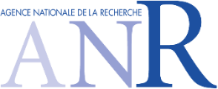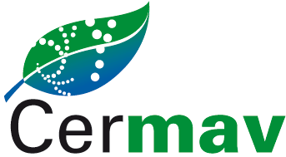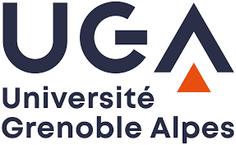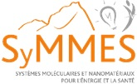

3 years PhD Position
Opening October 1st 2021, Grenoble, France

Glyco-Amphiphiles-Decorated Liquid Crystal Biosensor for Label-Free Detection of Lectins

A PhD position devoted to functional glyco-amphiphiles is available in October 2021 as a part of the French National Research Agency (ANR) collaborative project “SWEET-DISPLAY” coordinated by Dr. Sami Halila in Grenoble (France). This research project combine expertise and skills of CERMAV Lab [UPR5301-CERMAV (CNRS/Univ. Grenoble Alpes): Dr. S. Halila and Dr. A. Imberty: chemistry & physical-chemistry of Carbohydrates and Glycobiology] and SyMMES Lab [UMR5819-SyMMES (CEA/CNRS/Univ. Grenoble Alpes): Dr. P. Rannou: chemistry and physics of functional liquid crystals. The PhD position is funded for three years by ANR and can start in October 2021.

Mission
The transdisciplinary (Chemistry/Physics/Biology) “SWEET-DISPLAY” project spans from original access towards glyco-amphiphiles, through self-assembly and lectin interactions in solution up to the fabrication & characterization of liquid crystals-based biosensors. The PhD candidate will be in charge of optimizing protecting-free functionalization of carbohydrates issues and to perform the detailed characterization of glyco-amphiphiles for developing a liquid-crystal-based carbohydrate biosensor for lectin/pathogen detection. The PhD will benefit from state-of-the-art processing and characterization platforms available within CERMAV & SyMMES labs to develop her/his research on carbohydrate chemistry and their interactions with specific lectins from pathogens and will facilitate the implementation towards liquid crystals-based biosensors by interacting with our partners.

Candidate’s profile
The PhD candidate should preferably hold a Master degree in organic chemistry with a first experience in a Laboratory on modification and characterization of carbohydrates interacting with carbohydrate-binding proteins. Knowledges on binding assays or/and liquids crystals are expected. She/He must be an enthusiastic and dynamic researcher with scientific creativity. Excellent communication and writing (English) skills are equally important criteria with respect to academic qualifications and scientific merit for the selection of the PhD.

e-Application: Application file, selection process, and timeline
Applicant should provide an e-application file combining a curriculum vitae (including publications), a letter of motivation, grades obtained in master’s degree and a summary of their research experience. A single pdf should be addressed to Dr. Sami Halila: sami.halila@cermav.cnrs.fr. The applicants should arrange that at least one reference letter is sent directly to the contact address above. The deadline for the application is end of August 2021. We encourage candidates to apply as soon as possible.

